**Karan Arora**  **R.L. Institute M: 9416974837**

**Subject: Biology**

**Topic: Gymnosperms & Angiosperms**

**M.M. 180 COMPETITIVE TEST**  **Time: 45 Min.**

1. Which is the tallest gymnospermic plant

|  |  |  |  |
| --- | --- | --- | --- |
| a) Sequoia | b) Cycas | c) Pinus | d) Ginkgo |

1. In gymnosperm roots are generally :

|  |  |  |  |
| --- | --- | --- | --- |
| a) Fibrous root | b) Adventitious root | c) tap root | d) Prop root |

1. In which of the following gymnosperms carolloid root having N2-fixation cyanobacteria (Nostoc) is found

|  |  |  |  |
| --- | --- | --- | --- |
| a) Pinus | b) Ginkgo | c) Cycas | d) Cedrus |

1. Branched stem is found in :

|  |  |  |  |
| --- | --- | --- | --- |
| a) Cycas + Pinus | b) Cycas + Cedrus | c) Pinus + Cedrus | d) Cycas |

1. The leaves of gymnosperms are well adapted to withstand extremes of temperature, humidity and wind. In conifers what are the xerophytic characters :

|  |  |  |  |
| --- | --- | --- | --- |
| a) Needle like leaves | b) Thick cuticle | c) Sunken stomata | d) All of these |

1. All have archegonia except :

|  |  |  |  |
| --- | --- | --- | --- |
| a) Bryophytes | b) Pteridophytes | c) Gymnosperm | d) Angiosperm |

1. Megaspore mother cell undergo _________ division to form megaspore.

|  |  |  |  |
| --- | --- | --- | --- |
| a) Mitosis | b) Meiosis | c) Amitosis | d) Dinomitosis |

1. Megaspore develops into multicellular structure is called :

|  |  |
| --- | --- |
| a) Male gametophyte | b) Microspore mother cell |
| c) Female gametophyte | d) Megaspore mother cell |

1. In gymnosperm, pollination takes place by :

|  |  |  |  |
| --- | --- | --- | --- |
| a) Wind | b) Water | c) Insects | d) Animals |

1. *Chilgoza* are used as a fruit is obtained form

|  |  |  |  |
| --- | --- | --- | --- |
| a) Pinus | b) Cycas | c) Gnetum | d) Angiosperm |

1. Source of Canada balsam (a mounting agent to make permanent slide) is obtained from :

|  |  |  |  |
| --- | --- | --- | --- |
| a) Abies | b) Pinus | c) Cedrus | d) Angiosperm |

1. Both antheridia and archegonia are absent in

|  |  |  |  |
| --- | --- | --- | --- |
| a) Angiosperm | b) Bryophytes | c) Pteridophytes | d) Algae |

1. Ploidy level of endosperm of gymnosperm and angiosperm are

|  |  |  |  |
| --- | --- | --- | --- |
| a) n , 2n | b) n , n | c) n , 3n | d) 3n , n |

1. Basal (swollen) part of pistil is called

|  |  |  |  |
| --- | --- | --- | --- |
| a) Stigma | b) Style | c) Ovary | d) None of these |

1. One anther lobe contains _____ sporangium

|  |  |  |  |
| --- | --- | --- | --- |
| a) 1 | b) 2 | c) 3 | d) 4 |

1. Female gametophyte of angiosperm contains ______ nuclei

|  |  |  |  |
| --- | --- | --- | --- |
| a) 5 | b) 7 | c) 8 | d) 9 |

1. Double fertilization is characteristics of

|  |  |  |  |
| --- | --- | --- | --- |
| a) Angiosperm | b) Gymnosperm | c) Pteridophytes | d) None of these |

1. Male gametophyte in gymnosperm consist _____ male gamete

|  |  |  |  |
| --- | --- | --- | --- |
| a) 1 | b) 2 | c) 3 | d) 4 |

1. How many nuclei participates in double fertilization

|  |  |  |  |
| --- | --- | --- | --- |
| a) 2 | b) 3 | c) 4 | d) 5 |

1. Vegetative and generative cells are found in

|  |  |  |  |
| --- | --- | --- | --- |
| a) Male gametophyte | b) female gametophyte | c) Ovary | d) Stigma |

1. In angiosperm, 1 microspore mother cell give rise to ______ gametes

|  |  |  |  |
| --- | --- | --- | --- |
| a) 2 | b) 4 | c) 8 | d) 10 |

1. Generative fertilization is also called as

|  |  |  |  |
| --- | --- | --- | --- |
| a) Triple fusion | b) Syngamy | c) Zoodiophily | d) None of these |

1. Wolfia is ________ plant

|  |  |
| --- | --- |
| a) Smallest angiospermic plant | b) Largest angiospermic plant |
| c) Smallest gymnospermic plant | d) Largest gymnospermic plant |

1. The endosperm of angiosperm is

|  |  |  |  |
| --- | --- | --- | --- |
| a) Haploid | b) Diploid | c) Triploid | d) Tetraploid |

1. Pyncoxylic wood is found

|  |  |  |  |
| --- | --- | --- | --- |
| a) Cycas | b) Pinus | c) Eucalyptus | d) None of these |

1. Anther and filament are parts of :

|  |  |  |  |
| --- | --- | --- | --- |
| a) Androecium | b) Gynoecium | c) Both (a) & (b) | d) None of these |

1. Where are female sex organ / archegonia found in

|  |  |  |  |
| --- | --- | --- | --- |
| a) Micro gametophyte | b) Mega gametophyte | c) Microsporangium | d) Antheridium |

1. In gymnosperm male gametophyte is

a) Is highly reduced

b) Has an independent life

c) Is highly reduced and consist few cells i.e. in Cycas = 3 and Pinus = 4

d) Produced in microsporangiate cone

1. Match column I and column II

|  |  |
| --- | --- |
| Column I | Column II |
| A. Amphibians of plant kingdom | I. Sphagnum |
| B. Special structure in liverworts for asexual reproduction | II. Angiosperm |
| C. Monocotyledons and dicotyledonous | III. Bryophytes |
| D. A plant which has capacity of holding water | IV. Gemma |

|  |  |
| --- | --- |
| a) A – III ; B – IV ; C – I ; D – II | b) A – III ; B – IV ; C – II ; D – I |
| c) A – IV ; B – III ; C – II ; D – I | d) A – III ; B – II ; C – IV ; D – I |

1. In angiosperm pollen grain are land on

|  |  |  |  |
| --- | --- | --- | --- |
| a) Stigma | b) Style | c) Ovary | d) None of these |

1. Diplontic life cycle is observed in :

|  |  |  |  |
| --- | --- | --- | --- |
| a) Angiosperm | b) Gymnosperm | c) Both (a) & (b) | d) None of these |

1. Megaspore mother cells develops from :

|  |  |  |  |
| --- | --- | --- | --- |
| a) Nucellus | b) Archaegonium | c) Integument | d) None of these |

1. During embryo sac development, how many mitotic division occur to form embryo sac

|  |  |  |  |
| --- | --- | --- | --- |
| a) 1 | b) 2 | c) 3 | d) 4 |

1. Gynoecium consist of :

|  |  |  |  |
| --- | --- | --- | --- |
| a) Stigma | b) Style | c) Ovary | d) All of these |

1. Vegetative fertilization is also called as

|  |  |  |  |
| --- | --- | --- | --- |
| a) Triple fusion | b) Syngamy | c) Zoodiophily | d) None of these |

1. Entomophily (insect pollination) is common in

|  |  |  |  |
| --- | --- | --- | --- |
| a) Angiosperm | b) Gymnosperm | c) Both (a) & (b) | d) None of these |

1. The embryo sac of angiosperm is made up of

|  |  |  |  |
| --- | --- | --- | --- |
| a) 7 celled 8 nuclei | b) 8 celled | c) 8 nuclei | d) 7 celled 7 nuclei |

1. If the diploid number of a flowering plant is 36. What would be the chromosome number of endosperm

|  |  |  |  |
| --- | --- | --- | --- |
| a) 36 | b) 18 | c) 54 | d) 72 |

1. The endosperm of gymnosperm is

|  |  |  |  |
| --- | --- | --- | --- |
| a) Haploid | b) Diploid | c) Triploid | d) Tetraploid |

1. In angiosperm, functional megaspore is developed into

|  |  |  |  |
| --- | --- | --- | --- |
| a) Embryo sac | b) Ovule | c) Endosperm | d) Pollen sac |

1. In gymnosperm, seed are naked because they lack :

|  |  |  |  |
| --- | --- | --- | --- |
| a) Integuments | b) Pericarp | c) Nucellus | d) Perianth |

1. Life cycle of angiosperm is given below. Identify A, B, C, D and E marked in following figure

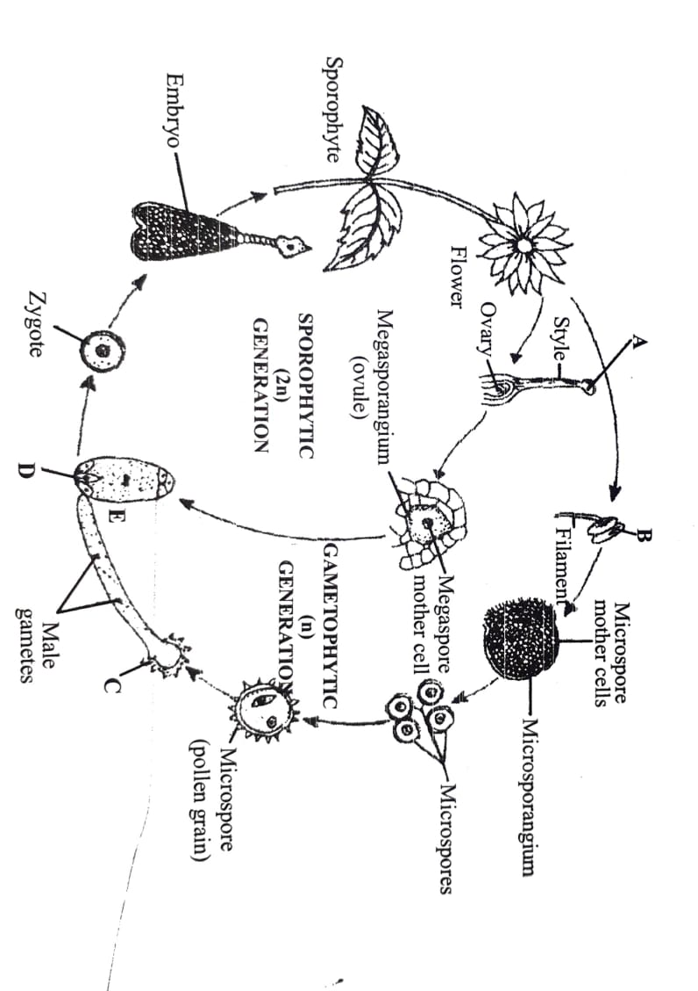

a) **A** – Stigma ; **B** – Anther ; **C** – Male gametophyte ; **D** – Egg ; **E** – Female gametophyte

b) **A** – Stigma ; **B** – Anther ; **C** – Female gametophyte ; **D** – Egg ; **E** – Male gametophyte

c) **A** – Stigma ; **B** – Anther ; **C** – Male gametophyte ; **D** – Fertilized egg ; **E** – Female gametophyte

d) **A** – Stigma ; **B** – Anther ; **C** – Embryo sac ; **D** – Egg ; **E** – Female gametophyte

1. Which of the following is living fossils

|  |  |  |  |
| --- | --- | --- | --- |
| a) Pinus | b) Ginkgo | c) Thuja | d) Deodar |

1. Coralloid roots of Cycas are useful in :

|  |  |  |  |
| --- | --- | --- | --- |
| a) N2-fixation | b) Absorption of water | c) Transpiration | d) All of these |

1. Match column I and column II

|  |  |
| --- | --- |
| Column I | Column II |
| A. Smallest flowering plant | I. Eucalyptus |
| B. Male sex organ in flowering plant | II. Wolfia |
| C. Female sex organ in flowering plant | III. Stamen |
| D. Facultative aerobes | IV. Pistil |

|  |  |
| --- | --- |
| a) A – I ; B – II ; C – III ; D – IV | b) A – IV ; B – III ; C – II ; D – I |
| c) A – II ; B – III ; C – IV ; D – I | d) A – II ; B – IV ; C – III ; D – I |

**[Class =11th]**

**Answers**

**Topic: Gymnosperms & Angiosperms**

|  |
| --- |
| 1. a |
| 1. c |
| 1. c |
| 1. c |
| 1. d |
| 1. d |
| 1. b |
| 1. c |
| 1. a |
| 1. a |
| 1. a |
| 1. a |
| 1. c |
| 1. c |
| 1. d |
| 1. c |
| 1. a |
| 1. a |
| 1. d |
| 1. a |
| 1. c |
| 1. b |
| 1. a |
| 1. c |
| 1. b |

|  |
| --- |
| 1. a |
| 1. b |
| 1. c |
| 1. b |
| 1. a |
| 1. c |
| 1. a |
| 1. c |
| 1. d |
| 1. a |
| 1. a |
| 1. a |
| 1. c |
| 1. a |
| 1. a |
| 1. a |
| 1. a |
| 1. b |
| 1. a |
| 1. c |